**Experiment 1:**

**Aim:** To analyse the performance of various configurations and protocols in LAN

**Requirements**

• Windows pc – 3Nos

• CISCO Packet Tracer Software

• 8 port switch – 1 No

• Cat-5 LAN cable

**Procedure**

• Open the CISCO Packet tracer software

• Drag and drop 3 pcs using End Device Icons on the left corner

• Select 8 port switch from switch icon list in the left bottom corner

• Make the connections using Straight through Ethernet cables

• Give IP address of the PC1, PC2 and PC3 as 192.168.1.1, 192.168.1.2 and 192.168.1.3 respectively, ping between PCs and observe the transfer of data packets in real and simulation mode.

**Theory**

A local area network (LAN) is a collection of devices connected together in one physical location, such as a building, office, or home. A LAN can be small or large, ranging from a home network with one user to an enterprise network with thousands of users and devices in an office or school. A LAN comprises cables, access points, switches, routers, and other components that enable devices to connect to internal servers, web servers, and other LANs via wide area networks. The advantages of a LAN are the same as those for any group of devices networked together. The devices can use a single Internet connection, share files with one another, print to shared printers, and be accessed and even controlled by one another.

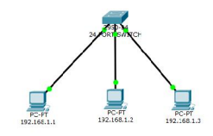

**Input Details for LAN**

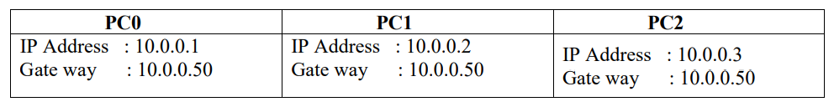

LAN OUTPUT WINDOW: (PINGING FROM PC0-PC1) Packet Tracer PC Command Line 1.0

C:\>ping 10.0.0.2

Pinging 10.0.0.2 with 32 bytes of data: Reply from 10.0.0.2: bytes=32 time=8ms TTL=128 Reply from 10.0.0.2: bytes=32 time=4ms TTL=128 Reply from 10.0.0.2: bytes=32 time=4ms TTL=128 Reply from 10.0.0.2: bytes=32 time=4ms TTL=128

Ping statistics for 10.0.0.2: Packets: Sent = 4, Received = 4, Lost = 0 (0% loss),

Approximate round trip times in milli-seconds: Minimum = 4ms,

Maximum = 8ms,

Average = 5ms

**LAN - MAC ADDRESS TABLE**

